Modeling Zero Energy Elementary Schools with OpenStudio®

OpenStudio® is a whole building energy modeling software platform used to model complex interactions between the building envelope, plug loads, daylighting, lighting, and heating and cooling equipment. It has an intuitive graphical user interface that helps the user navigate through different inputs for the energy model. A unique feature of OpenStudio® is that it provides the capability to quickly implement different energy efficiency and energy conservation strategies using a set of programmatic instructions called ‘measures. The purpose of using OpenStudio® for the Solar Decathlon Design Challenge is to evaluate the impact of these energy efficiency and energy conservation strategies on the energy use intensity (EUI) of the building and ensure that it is along the path to zero energy. The OpenStudio® software is available to download for free. ­

Table of Contents

Installing OpenStudio® 2

Loading Solar Decathlon Design Challenge Parametric Analysis Tool (PAT) Project and Running an Analysis 3

Next Steps 11

Overview of Measures in the Analysis Workflow 12

Helpful Resources 14

# Installing OpenStudio®

1. Go to <https://github.com/NREL/OpenStudio/releases/tag/v2.6.0> and under “Assets” for “OpenStudio v2.6.0” select the Windows or Mac installer.
   1. Windows installer ends with “Windows.exe”
   2. Mac installer ends with “Darwin.zip”
   3. Note: While there are newer installers please don’t use them when running the “PAT_SDDC_PrimarySchool” PAT project.
2. Run the installer, and make sure all OpenStudio components are selected as shown below.

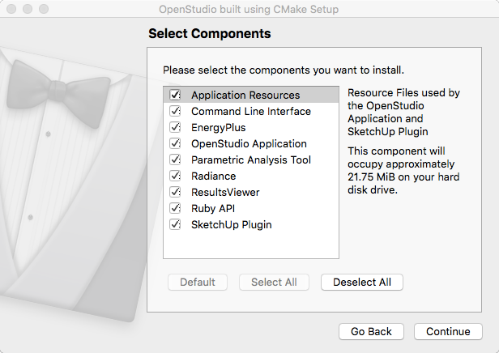

1. The OpenStudio® icon should now show up on the start menu on Windows or in your applications folder on Mac.

# Loading Solar Decathlon Design Challenge Parametric Analysis Tool (PAT) Project and Running an Analysis

Launch the Parametric Analysis Tool and load the “PAT_SDDC_PrimarySchool” project, this can be found on the Solar Decathlon web portal. Follow the instructions below, however if necessary, more instructions are available online.   
[*http://nrel.github.io/OpenStudio-user-documentation/reference/parametric_analysis_tool_2/#open-an-existing-project*](http://nrel.github.io/OpenStudio-user-documentation/reference/parametric_analysis_tool_2/#open-an-existing-project)

1. Launch PAT and click “Open Existing Project”.
2. Load a project by selecting the directory with the project name “PAT_SDDC_PrimarySchool”. There is no file to select, just browse to the top-level directory for the project and click “Open”.   
   
3. The project will load in the “Project Measures and Options” tab , which is the first tab. The PAT project is pre-populated with a workflow similar to what was used for NREL’s Technical Feasibility Study for Zero Energy K-12 Schools.



* 1. The “ZEDG K12 Primary TSD Seed.osm”, that is assigned as the “Default Seed Model”, includes the geometry and space types used for the Technical Feasibility Study for Zero Energy K-12 Schools
  2. Ignore the “Default Weather File” which is set for Fairbanks, we will set the weather file with the “Change Building Location” measure.
  3. Most of the measures, shown in the grey bars, are energy conservation measure, but some serve other purposes. Either way, you don’t have to change any of these at this point. If interested, you can click the black arrow at the left of each bar to expand these. Some have just one option, some have multiple options, but don’t change anything at this point.
  4. Most of the energy conservation measures have embedded space type or climate zone specific recommendations. There are no dials to make the recommendations more or less aggressive, but when you get to the next tab you can turn specific measures/recommendations off.
  5. Measures prefixed with “Aedg” were created to model the prescriptive recommendations of the 50% Advanced Energy Design Guide for K-12 School Buildings
  6. Measures prefixed with “ZEDG” were created for the Technical Feasibility Study for Zero Energy K-12 Schools as well as the subsequent Technical Support Document and Zero Energy Design Guide for K-12 Schools (TSD and ZEDG have not been published yet).
  7. Details on the function of additional measures are described in the “Overview of Measures in the Analysis Workflow” section later in this document.

1. Move to the “Design Alternatives” tab , which is the second tab. There are four design alternatives already setup, one for each of the three different mechanical systems used for the Technical Feasibility Study for Zero Energy K-12 Schools, and one is setup to create an ASHRAE 90.1 2007 baseline. Each row represents a design alternative.  
   (note: the ASHRAE 30% and 50% AEDG guides use 90.1 2004 vs. 90.12007 as a baseline. The K12 Zero Energy Feasibility Study doesn’t have a baseline, but it was included here for reference.)

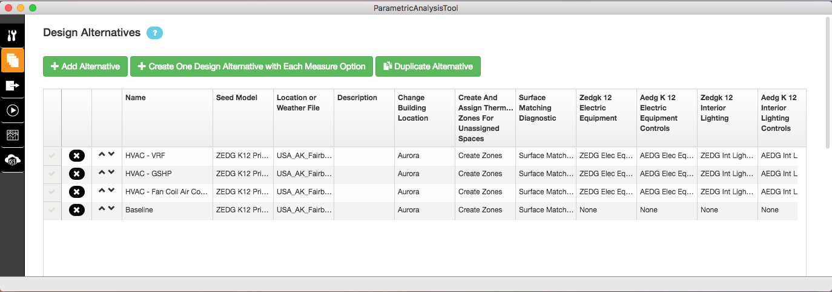

* 1. There is a column for each measure that appears on the first tab. For your initial run the first of two columns you need to change is “Change Building Location”. Clicking in one of those cells exposes a pull-down list with 16 different weather files from different climate zones. Choose the one that best represents the location for your building and assign it to all four design alternatives. The value in the “Location or Weather File” column is not used for this particular PAT project.  
     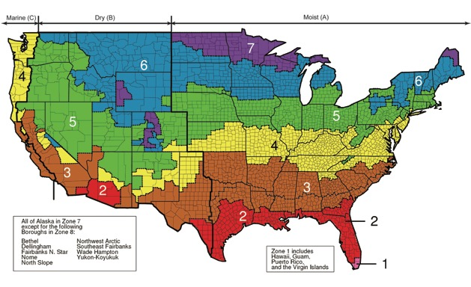

|  |  |  |
| --- | --- | --- |
| Climate Zone | Building Location | EnergyPlus Weather File |
| 0A* | Hanoi | VNM_Hanoi.488200_IWEC.epw |
| 0B* | Abu Dhabi | ARE_Abu.Dhabi.412170_IWEC.epw |
| 1A | Honolulu | USA_HI_Honolulu.Intl.AP.911820_TMY3.epw |
| 1B* | New Delhi | IND_New.Delhi.421820_ISHRAE.epw |
| 2A | Tampa | USA_FL_MacDill.AFB.747880_TMY3.epw |
| 2B | Tucson | USA_AZ_Davis-Monthan.AFB.722745_TMY3.epw |
| 3A | Atlanta | USA_GA_Atlanta-Hartsfield-Jackson.Intl.AP.722190_TMY3.epw |
| 3B | El Paso | USA_TX_El.Paso.Intl.AP.722700_TMY3.epw |
| 3C | San Diego | USA_CA_Chula.Vista-Brown.Field.Muni.AP.722904_TMY3.epw |
| 4A | New York | USA_NY_New.York-J.F.Kennedy.Intl.AP.744860_TMY3.epw |
| 4B | Albuquerque | USA_NM_Albuquerque.Intl.AP.723650_TMY3.epw |
| 4C | Seattle | USA_WA_Seattle-Tacoma.Intl.AP.727930_TMY3.epw |
| 5A | Buffalo | USA_NY_Buffalo-Greater.Buffalo.Intl.AP.725280_TMY3.epw |
| 5B | Aurora | USA_CO_Aurora-Buckley.Field.ANGB.724695_TMY3.epw |
| 5C | Port Angeles | USA_WA_Port.Angeles-William.R.Fairchild.Intl.AP.727885_TMY3.epw |
| 6A | Rochester | USA_MN_Rochester.Intl.AP.726440_TMY3.epw |
| 6B | Great Falls | USA_MT_Great.Falls.Intl.AP.727750_TMY3.epw |
| 7 | International Falls | USA_MN_International.Falls.Intl.AP.727470_TMY3.epw |
| 8 | Fairbanks | USA_AK_Fairbanks.Intl.AP.702610_TMY3.epw |

* Climate Zones 0A, 0B, and 1B will show blank in the OpenStudio application, and are not valid options for the “Create Baseline Building” measure.

* 1. The second column you need to change is “Create Baseline Building”. The only design alternative to alter is the one named “Baseline”. Select the climate zone to match the climate Zone of the city you chose for “Change Building Location”.
     1. If you don’t want to have a baseline to compare against the high-performance models you can delete this design alternative by clicking the black “x” at the far left of the row.
     2. One of the ZEDG system types is selected for this “Baseline” design alternative for use in fuel type selection within the baseline measure.
  2. System Type descriptions.
     1. Variable Refrigerant Flow (VRF) with DOAS: A variable refrigerant flow system has several indoor units connected to an outdoor unit. This allows for capacity variation and simultaneous heating and cooling. Each zone in the model was served by a VRF indoor terminal unit and the Dedicated Outdoor Air System (DOAS). Kitchen, gym and the cafeteria were served by their own outdoor units.
     2. Ground Source Heat Pump (GSHP) with DOAS: Each zone served by the DOAS (classrooms, corridors, library/media center, lobbies, mechanical rooms, offices, and restrooms) was modeled with a two-speed GSHP.
     3. Air Handler with Chiller, Gas-fired Boiler and DOAS: Air handler with an air-cooled chiller, gas-fired boiler and DOAS is a widely used HVAC system in schools and was thus included in the analysis.

1. The third tab, “Outputs” , is only use for algorithmic analyses, it isn’t used for this project.
2. Move to the “Run” tab , which is the forth tab.   
     
   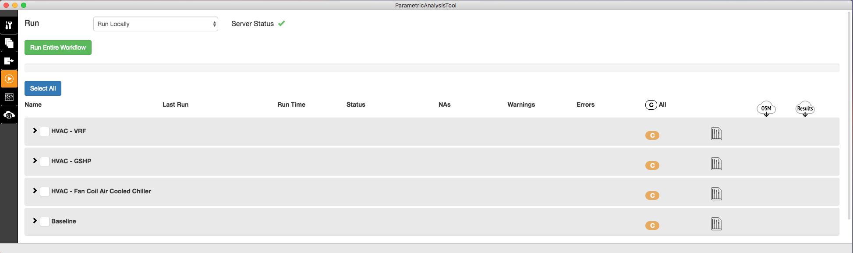
   1. Wait for the “Server Status” to change from a red x to a green checkmark. This takes a few minutes after you fist launch a PAT project.
   2. Click “Run Entire Workflow”.
   3. While the simulations are running, you can’t switch to another tab.
3. When the status for a specific design alternative shows “completed Success” you can click on the icon near the right with the mini bar chart  to view HTML reports for that design alternative. The “openstudio_results_report” gives a quick annual and monthly overview.
   1. You can use the Total Site EUI (energy consumed before PV), the Net Site EUI, and the annual end use breakdown percentages to help you develop EUI targets by end use.
   2. Clicking the blue box above a chart will open up a tabular view of that same data.  
        
      
   3. The Envelope summary provides detail on envelope performance and window to wall ratio.  
        
      (Note: the base surface construction names do not reflect their current performance. The construction names were not altered when the performance was altered)
4. The envelope_and_internal_load_breakdown_report provides a breakdown of heat gain by component for the building envelope and internal loads. There is a similar report for heat losses.  
     
   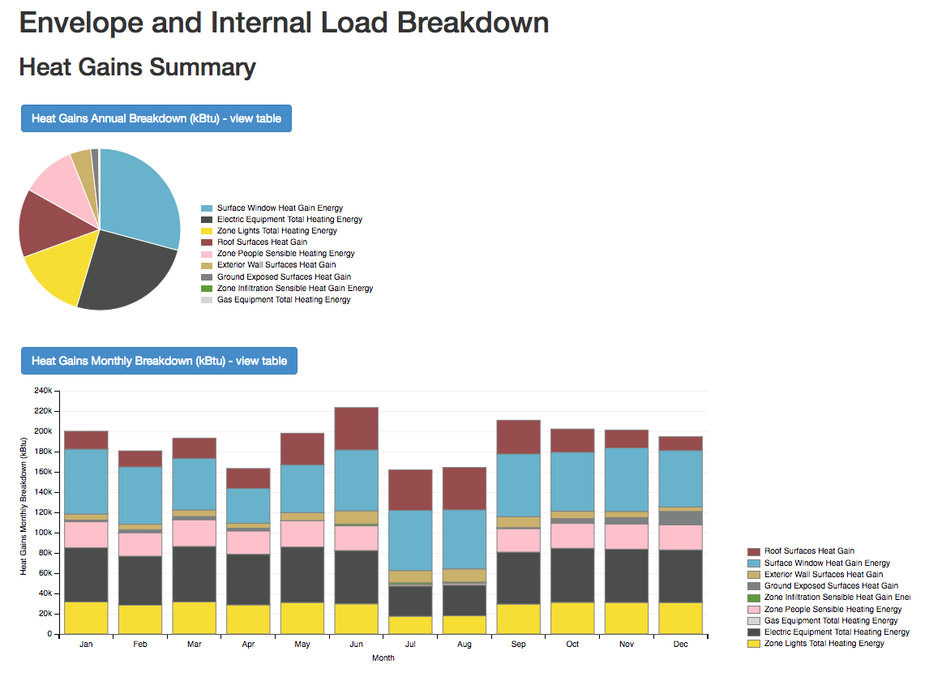
5. To see log messages for individual measures, fist click on an empty portion of the grey bar for a specific design alternative, to list the measures, then click a measure to expand and view its log messages.   
   
6. The “Reports” tab , which is the fifth tab, provides an overview across all design alternatives.
   1. The “Summary Table” report compares all design alternatives against a “baseline”, presented in the top row. If you ran the design alternative named “Baseline” then choose that in the pull-down menu under the “Name” column to set it as the baseline for the comparison. Measures that have common values across all design alternatives are not listed under the “Measures” column. 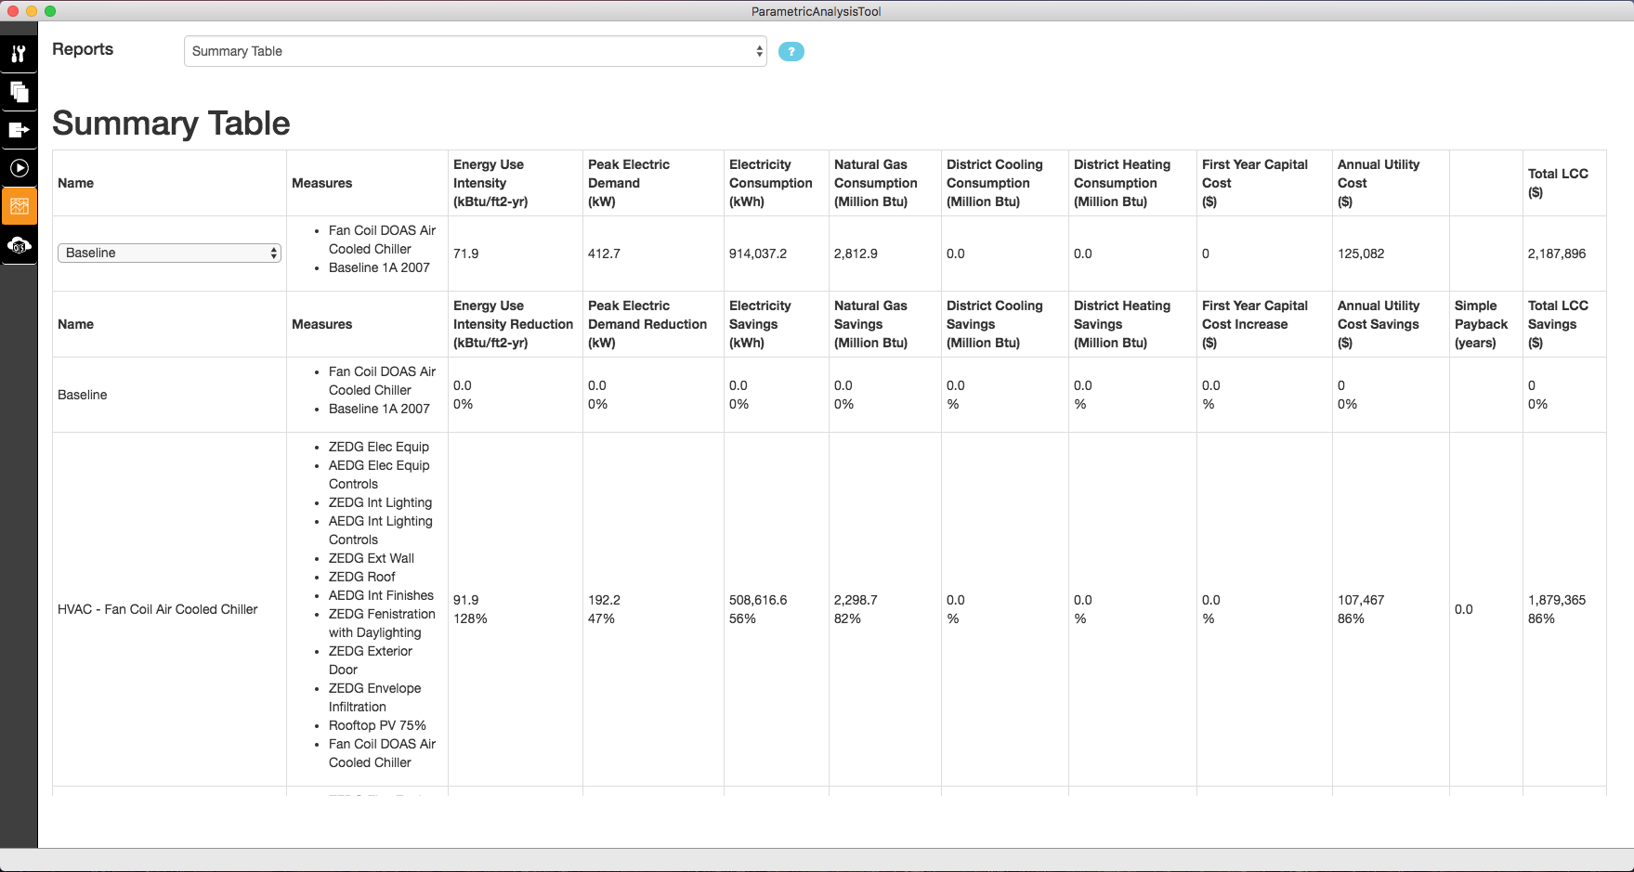
   2. Changing the report selector, at the top, to “End Use Comparison” shows stacked bar charts with consumption by fuel across design alternatives.   
      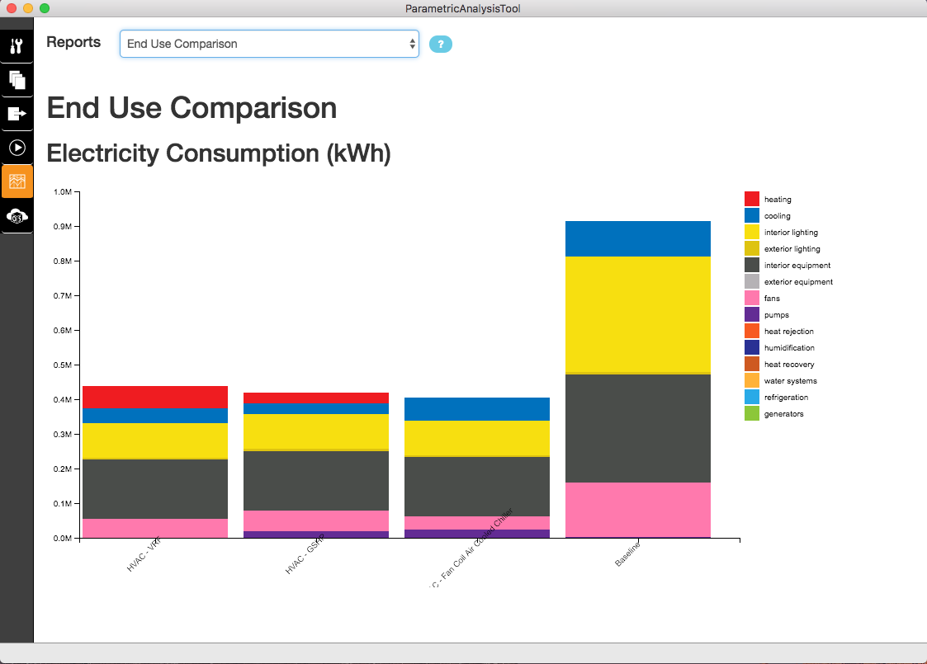
7. The “Server” tab , which is the last tab, provides another view into the results. This tab shouldn’t be used for most users.

# Next Steps

This analysis, run for your climate zone, may provide you all the information you need to create end use EUI targets and envelope construction recommendations; but if not, and if you would like to explore design options further, here are some next steps you may want to consider.

1. Disable some of the ZEDG or AEDG energy efficiency measures to see how much they impact the results.
   1. You can do this by going back to the “Design Alternatives” tab, and either altering existing design alternatives or making new ones by clicking “+ Add Alternative” or “Duplicate Alternative” buttons. Don’t click “+Create One Design Alternative with Each Measure Option” It won’t be useful for this particular analysis and will create a bunch of invalid design alternatives each with just one measure turn on.
   2. Find the column for the measure option you want to change and set it to “none” instead of the value it currently has, which should be something like “ZEDG Elec Equip”.
   3. “Add Rooftop PV” has various options for percentage of roof covered with PV. You can switch between 50%, 75%, 100% or can add options for any other percentage coverage you want or can change cell and inverter efficiency values.
   4. Don’t disable the Service Water Heating (SWH), Kitchen, Exterior Lighting, Elevator, Electric Kiln, or Thermostat measures, since those loads and controls won’t otherwise be in the model.
   5. Don’t apply more than one mechanical system to the workflow.
2. You can open the OpenStudio Model (OSM) for any of your design alternatives in the OpenStudio application.
   1. The files will be in the “LocalResults” folder of your PAT project.
   2. Expand the design alternative so you can see list of measures. Make a note of the “Datapoint ID”. That is a sub-folder within “LocalResults” that has the model named “in.osm”.
   3. Launch the OpenStudio Application and then load the OSM file.
   4. At this point you can inspect the model and make changes to it.
   5. If you make changes use “SaveAs” under the file menu and select a location somewhere outside of your PAT project directory.
   6. Prior to running the simulation, you will need to re-connect it to the “epw” weather file found in the “weather” folder within your PAT project. You can find instructions for that here.   
      [*http://nrel.github.io/OpenStudio-user-documentation/tutorials/creating_your_model/#site*](http://nrel.github.io/OpenStudio-user-documentation/tutorials/creating_your_model/#site)
   7. You will also want to add the “OpenStudio Results” measure back into the workflow.   
      [*http://nrel.github.io/OpenStudio-user-documentation/tutorials/creating_your_model/#using-the-measures-tab*](http://nrel.github.io/OpenStudio-user-documentation/tutorials/creating_your_model/#using-the-measures-tab)
   8. Instructions are available online for running simulations from the OpenStudio application.   
      [*http://nrel.github.io/OpenStudio-user-documentation/tutorials/running_your_simulation/#running-a-simulation*](http://nrel.github.io/OpenStudio-user-documentation/tutorials/running_your_simulation/#running-a-simulation)

# Overview of Measures in the Analysis Workflow

1. OpenStudio Measures (these pass an OpenStudio model, alter it, and pass a modified OpenStudio model out)
   1. Change Building Location
      1. Changes weather file, design days, water main temperatures, and climate zone. The proper climate zone is important for how many of the other measures work. Typically, this will be set by “Lookup From Stat File”.
   2. Create and Assign Thermal Zones for Unassigned Spaces
      1. This measure is not necessary with the default seed model but is useful if you create a seed model with your own geometry. It allows you to just create space and assign space types without also creating thermal zones and assigning spaces to them.
   3. Surface Matching Diagnostic
      1. This measure is not necessary with the default seed model but is useful if you create a seed model with your own geometry. It will create thermal connections between adjacent spaces in your model.
   4. ZEDG K12 Electric Equipment
      1. Applies space type specific Electric Power Density (EPD).
   5. AEDG K12 Electric Equipment Controls
      1. Adjusts operational behavior of electric equipment.
   6. ZEDG K12 Interior Lighting
      1. Applies space type specific Lighting Power Density (LPD).
   7. AEDG K12 Interior Lighting Controls
      1. Adjusts operational behavior of interior lighting.
   8. ZEDG K12 Exterior Wall Construction
      1. Adds or increases exterior wall insulation as necessary based on ZEDG recommendations.
   9. ZEDG K12 Roof Construction
      1. Adds or increases roof insulation as necessary based on ZEDG recommendations. May also adjust Solar Reflectance Index (SRI).
   10. ZEDG K12 Interior Finishes
       1. Increases reflectiveness of high walls.
   11. ZEDG K12 Fenestration and Daylighting Controls
       1. Replaces fenestration on the building, adding in both view and daylighting windows.
       2. Daylight windows will only be on the north and south facades.
       3. South view windows will have an overhang, and south daylight windows will have a light shelf.
       4. For View windows North and South exposure will be preferred, but if necessary, will be added on east and west, but with internal shading controls.
       5. There is space type specific logic for window assignments.
   12. ZEDG K12 Exterior Door Construction
       1. Adds or increases exterior door insulation as necessary based on ZEDG recommendations.
   13. ZEDG K12 Envelope Infiltration
       1. Sets infiltration rate per exterior wall area.
   14. ZEDG K12 SWH (Service Water Heating)
       1. Replaces service water heating demand and supply.
   15. ZEDG K12 Kitchen
       1. Replaces kitchen lighting, equipment, and exhaust.
   16. AEDG K12 Exterior Lighting
       1. Applies lighting allowance based on user specified areas for façade lighting, parking and drives, and walkway lighting.
   17. Add Electric Equipment Instance to Space (Elevator)
       1. Adds electric equipment so specific space in model, in this instance elevators to mechanical room on first floor.
   18. Add Electric Equipment Instance to Space (Electric Kiln)
       1. Adds an electric kiln to the art room.
   19. Add Rooftop PV
       1. Creates shading surfaces with photovoltaics above the roof. There are arguments for cell and inverter efficiency for fraction of roof covered.
       2. Note, that the surface will always be the size of the entire roof even if fraction is less than 1.0, but the surface is model as translucent surface matching the PV fraction.
   20. Set Thermostat Schedules (whole building)
       1. Assigns heating and cooling thermostats schedules to all zones in the model
   21. Set Thermostat Schedules 2 (Gym has unique thermostat)
       1. Assigns custom heating and cooling thermostat schedules to the gym.
   22. ZEDG VRF with DOAS
   23. ZEDK K12 HVAC GSHP with DOAS
       1. Each zone served by the DOAS (classrooms, corridors, library/media center, lobbies, mechanical rooms, offices, and restrooms) is modeled with a two-speed GSHP. Secondary spaces also use GSHP.
   24. ZEDG K12 HVAC Fan Coil DOAS Air Cooled Chiller
       1. Measure replaces existing HVAC system (if any) with a Fan Coil with DOAS HVAC with air cooled Chiller system (one DOAS per floor).
   25. Create Baseline Building
       1. This is used to create an ASHRAE 90.1 baseline of an existing model. For this measure to run properly the model should already have a mechanical system. While this system is replaced, it is needed to identify fuel type.
       2. Note: Create Baseline Building can’t be run for Climate zones 0A, 0B, and 1B. You can skip this measure for those climate zones or substitute another similar climate zone.
2. EnergyPlus measures (these run after the OpenStudio OSM is converted to an EnergyPlus IDF file)
   1. ZEDG K12 Insert Ground Domain E+ Kusdua
      1. Adds objects for modeling of ground temperatures.
   2. Tariff Selection-Flat
      1. Adds user customizable flat tariff rates for different fuels.
3. Reporting Measures (these run on EnergyPlus Sql database after simulation is done to produce an html file)
   1. OpenStudio Results
      1. Annual and monthly simulation results
   2. Envelope and Internal Load Breakdown
      1. Heat gain and heat loss summary by building component. Doesn’t currently include ventilation.

Note: ­“Artroom” is not a recognized space type by the AEDG or ZEDG measures, and will not have lighting and plug loads altered. There is a specific measure in the workflow to add a kiln to the model. The “Artroom” space type includes typical lighting and occupancy.

# Helpful Resources

* OpenStudio® user documentation   
  <http://nrel.github.io/OpenStudio-user-documentation/>
* Installation and introductory tutorial   
  <http://nrel.github.io/OpenStudio-user-documentation/getting_started/getting_started/>
* Parametric Analysis Tool Documentation   
  <http://nrel.github.io/OpenStudio-user-documentation/reference/parametric_analysis_tool_2/>
* Technical Feasibility Study for Zero Energy K-12 Schools <https://www.nrel.gov/docs/fy17osti/67233.pdf>
* Technical Support Document for Zero Energy K-12 Schools will be published at a later date.
* [ASHRAE Zero Energy Design Guide for K-12 Schools](https://www.ashrae.org/technical-resources/aedgs/zero-energy-aedg-free-download)
* UnmetHours (please use tag “solar-decathlon” when posting questions. Only post energy modeling questions, not Solar Decathlon Design Challenge questions.)   
  <https://unmethours.com/questions/>
* [SDdesign@nrel.gov](mailto:sddesign@nrel.gov)